FOR IMMEDIATE RELEASE Media Contact:
Patricia Darragh, Executive Director
oliveoil@cooc.com
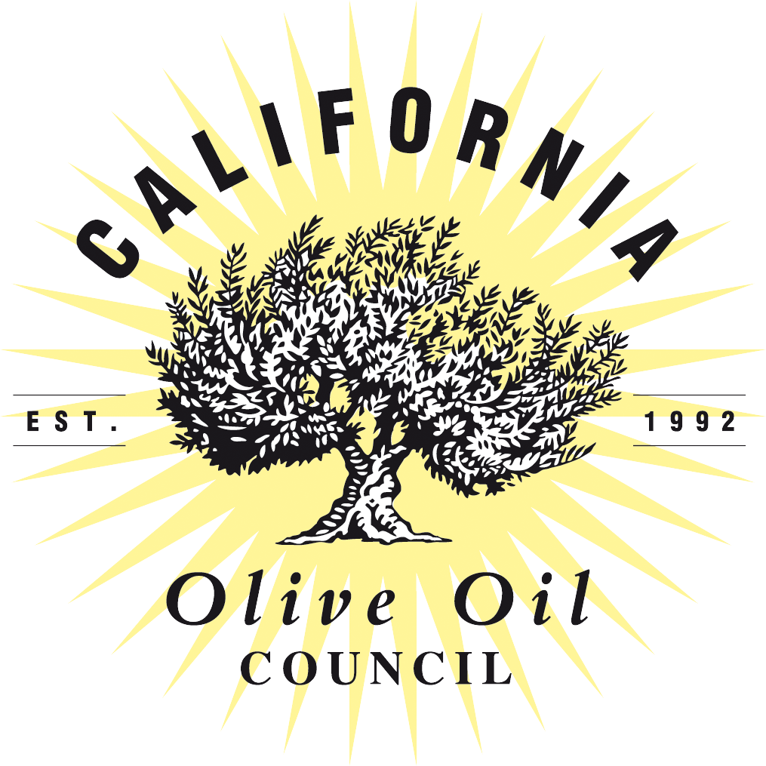

Roberta Klugman Receives the 2017 California Olive Oil Council Pioneer award
Industry veteran joins roster of distinguished olive oil pioneers

May 2, 2018, Monterey, Calif.—In receiving the California Olive Oil Council’s (COOC) 2017 Pioneer Award, Roberta Klugman, who began advocating as an educator and tastemaker for extra virgin olive oil in the 1980s, and who has supported the COOC for over 20 years, joins a distinguished list.

“I have been championing extra virgin olive oil since my early career when I was working at Narsai’s Market in Kensington, California when quality oil was found only at few specialty food shops.” Klugman says. She has been advocating for extra virgin olive oil ever since and has been an active participant in the resurgence of what now is the California olive oil industry
“Educating American food professionals, chefs, and consumers about extra virgin olive oil has been a passion of mine,” she says. Even before there was a COOC, she showcased California olive oils to chefs and consumers alike. While at the American Institute of Wine & Food, Klugman made a point of including California EVOO at international conferences on gastronomy, chapter programs, Smithsonian Associates travel programs, industry seminars, and consumer classes.
Klugman has served on the Board of the COOC, heading up strategic planning and marketing initiatives. Over the years, she created olive oil seminars with Les Dames d’Escoffier, the International Association of Culinary Professionals, the San Francisco Professional Food Society and at businesses such as Google. She promotes olive oil whenever she can to everyone. Linda Sikorski, senior buyer at Market Hall Foods, noted when presenting the award to Klugman, “Just go out to dinner with Roberta and see. If the chef is not already into California olive oil, she’ll make a convert!”
“I have had the good fortune of working with and learning from many visionaries in the industry over the years,” Klugman says. She adds that the growers and millers are doing the heavy lifting that has catapulted California olive oil into national and international attention and most importantly, made it available across the country. With their commitment to meeting and exceeding standards, “Our oils now hold their own with the most respected extra virgin olive oils in the world.”
Klugman says her ongoing mission has three components: Everyone should have three EVOOs in their kitchens and use it abundantly, in all manner of cooking, destroying the myth of not cooking with EVOO; recipes should call for extra virgin olive oil, not simply olive oil; and everyone should know to look for that harvest date and the COOC Seal.
The Pioneer Award was established in 1999 to recognize those who have made a major contribution to the California olive oil industry and the COOC. Klugman says she is honored to find herself among previous pioneers who represent innovative growers, producers, culinary educators, and tastemakers. “To do what you believe in and love is in itself rewarding,” she says. “To be recognized in this manner by others with a deep understanding of the industry is a highlight of my career.”

